Summary of MFG’s Strategic Direction
2016-2019
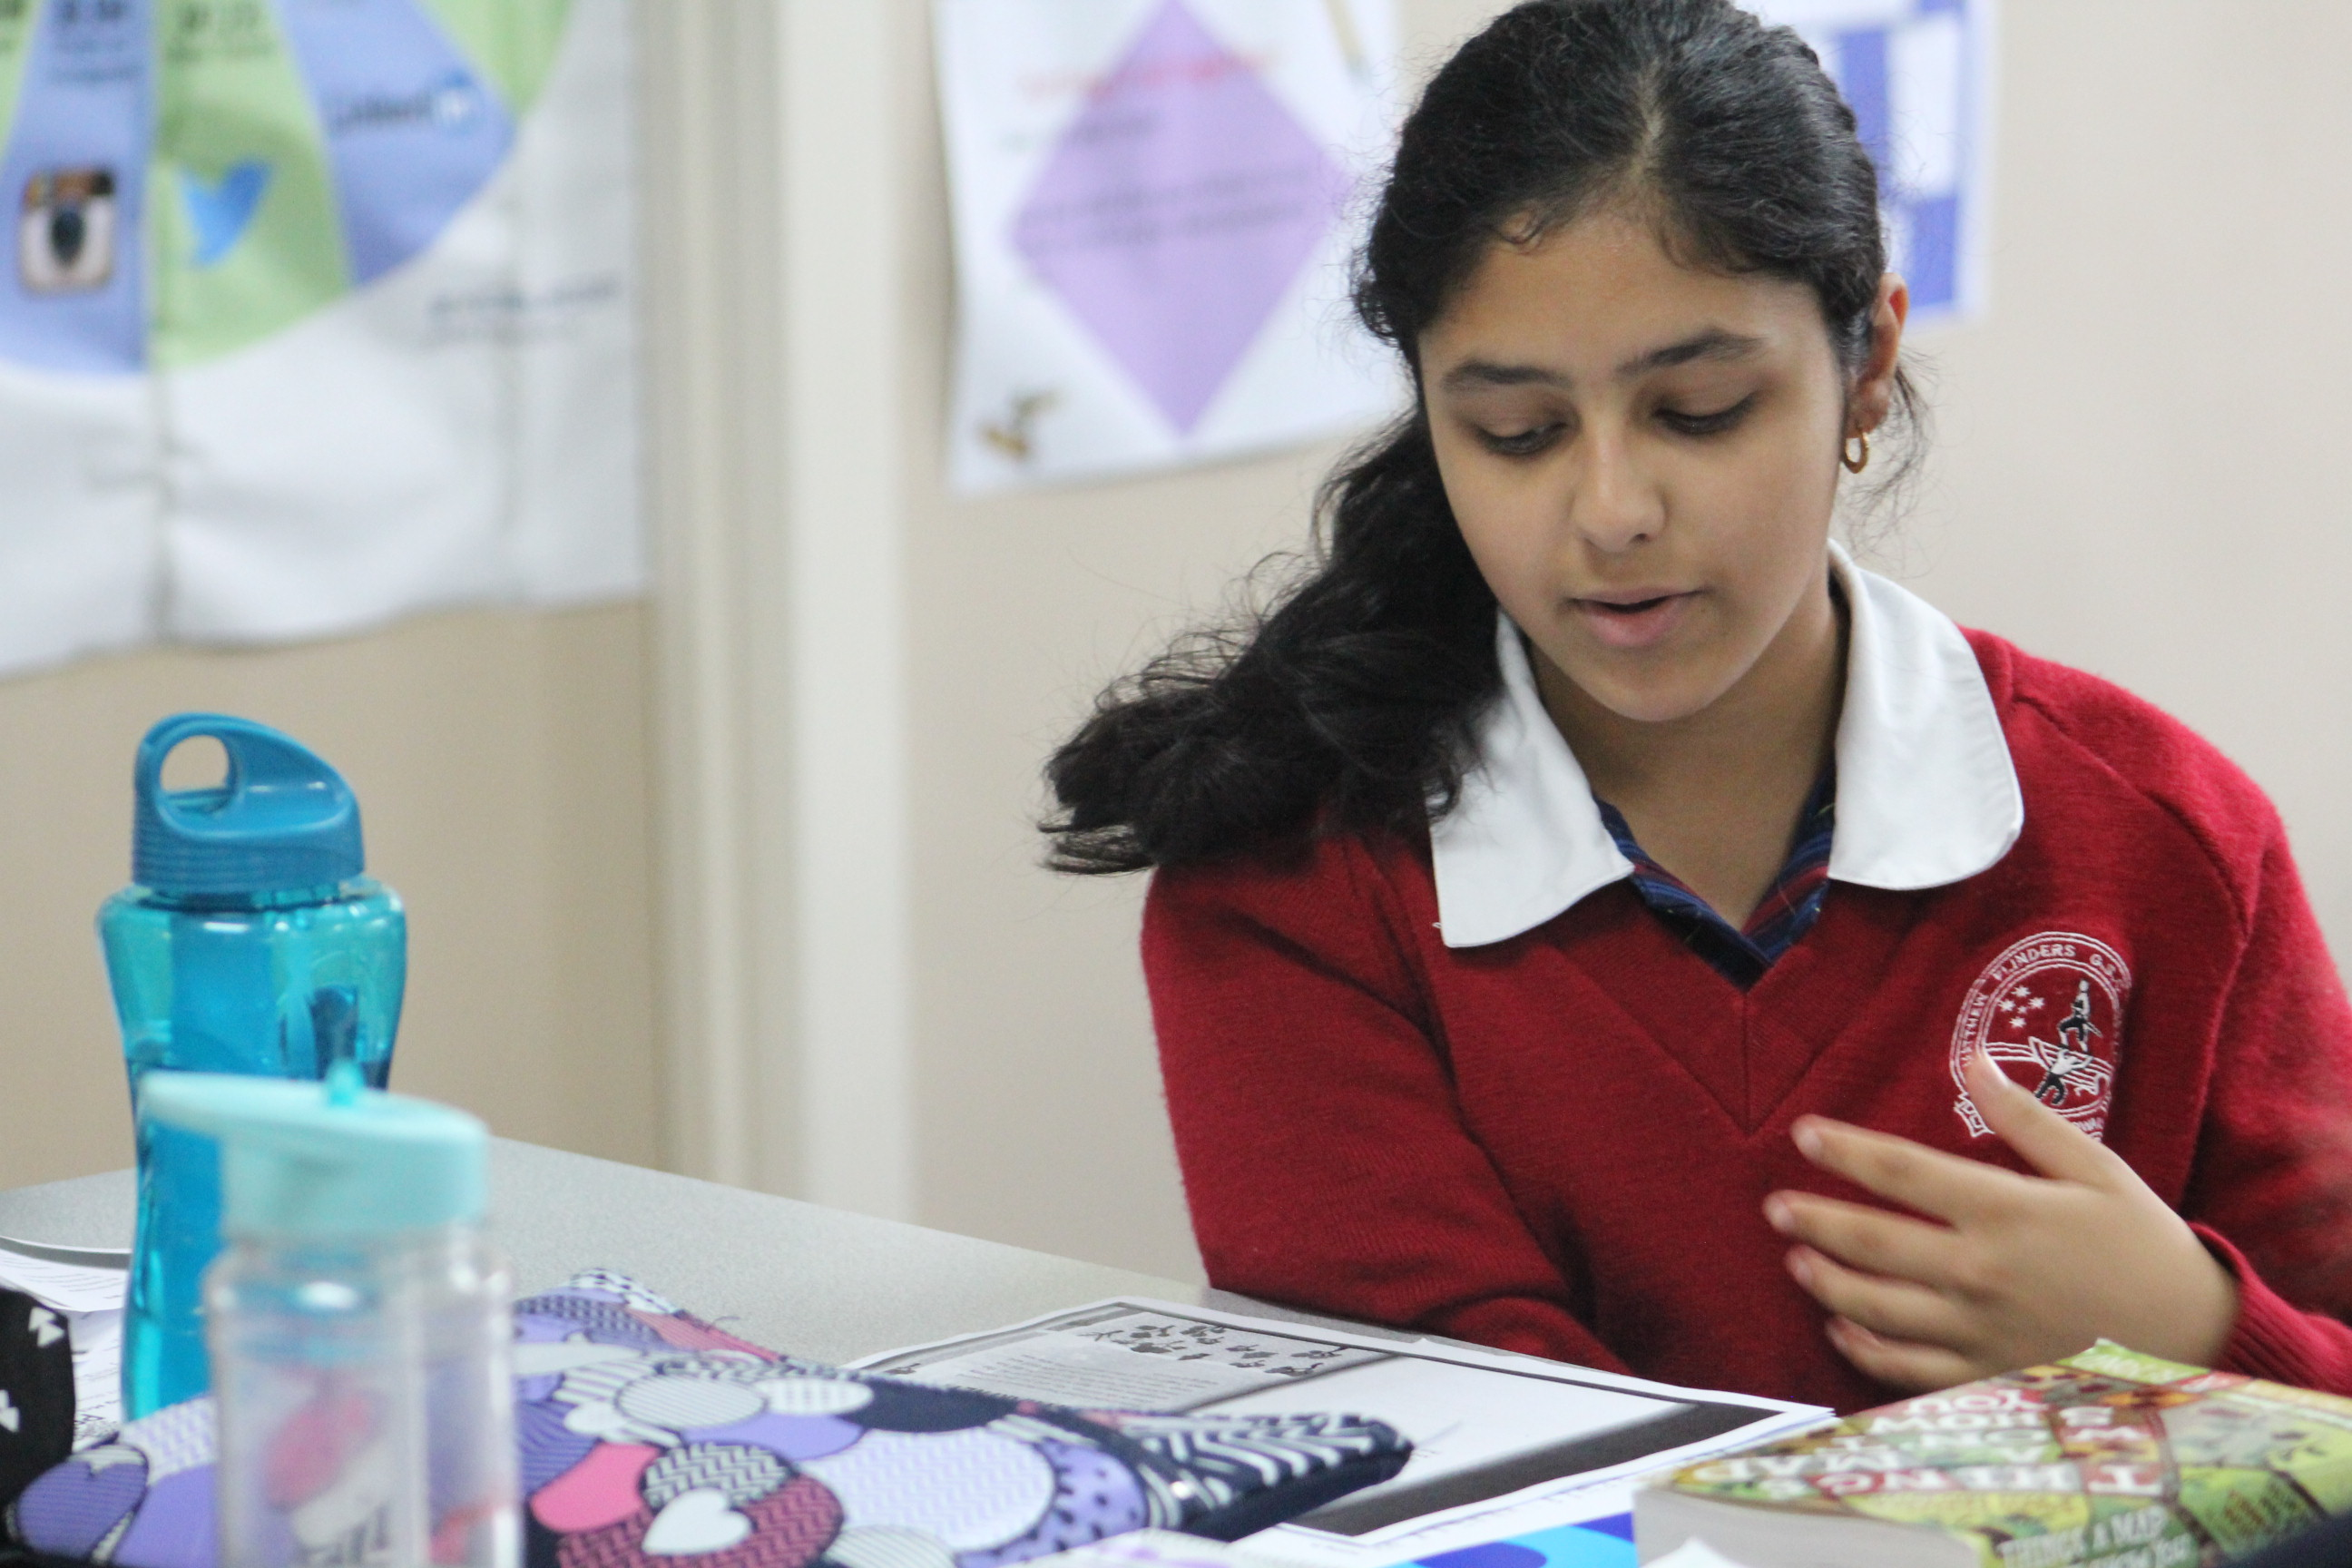

Excellence in Teaching and Learning

Excellence in teaching and learning:  -Building practice excellence  -Curriculum planning and assessment |  | Key Improvement Strategies
Goal | GOAL T&L1: To improve student learning outcomes.
Targets  By 2019 we will: | TARGET T&L1-1: Improve Teacher Guaranteed and Viable Curriculum scores on the Staff Survey from a Prin/Teacher endorsement of 45% in 2014 to 70%. |  | KIS T&L1-1: Establish a guaranteed viable curriculum.
 | TARGET T&L1-2: Improve Teacher Collective Focus on Learning scores on the Staff Survey from a Prin/Teacher endorsement of 57% in 2014 to 70%. |  | KIS T&L1-2: Continue to build teacher capacity to deliver consistent high quality teaching and learning and feedback, which is informed by data, in all areas of the school
 | TARGET T&L1-3: Increase the VCE All Median Study Score from 29 to 30.
 | TARGET T&L1-4: Increase the percentage of combined All Study Scores of 30 or above from 42.8% in 2014 at or above 50%.
 | TARGET T&L1-5: Increase the average Reading and Writing NAPLAN growth data from Years 7 -9 equivalent to or better than the State
 | TARGET T&L1-6: Increase the proportion of students making high relative NAPLAN gain in Spelling as those students progress from Year 7 to Year 9 from 19.8% in 2014 to 25% or more.
 | TARGET T&L1-7: Increase the average Numeracy NAPLAN growth data from Years 7 -9 equivalent to or better the State.  TARGET T&L1-8: Increase the proportion of students making high relative NAPLAN gain in Numeracy as those students progress from Year 7 to Year 9 from 9.9% in 2014 to 25% or more. |  | KIS T&L1-3-: Build teacher capacity to plan, deliver and assess STEAM skills, knowledge and understandings

Professional Leadership

Professional Leadership |  | Key Improvement Strategies
Goals | GOAL PL1: To foster a culture of collaboration.  GOAL PL2: To improve the effective allocation of resources across the school to support the best possible outcomes for students.
Targets  By 2019 we will: | TARGET PL1  Improve Teacher Collaboration scores on the Staff Survey from a whole school endorsement of 43% in 2014 to 70%. | KIS PL1  Foster a professional collaborative school culture so that professional conversations are evidence based and focused on improving student learning outcomes.
 | TARGET PL2  A surplus of the SRP of $40 000 is retained in the SRP to implement the Strategic Plan. | KIS PL2:  Create and implement processes and procedures that support quality planning and decision making.

Positive Climate for Learning

Positive climate for learning:  -Empowering students and building school pride  -Setting expectations and promoting inclusion |  | Key Improvement Strategies
Goal | GOAL PCL1: To improve our students’ connection to school, motivation to learn and engagement in their learning.  GOAL PCL2: To improve the wellbeing of the members of our school community.
Targets  By 2019 we will: | TARGET PCL1-1: Reduce the mean number of non-attendance days from an average of 17.79 to 15 days per year. | KIS PCL1-1  Build a culture where attending school is seen by the school community as important.
 | TARGET PCL1-2: Increase students exiting into further education or full time workplace learning from 86.4% in 2014 to an overall score of 95%. | KIS PCL1-2  Create a culture and programs that fosters aspiration by exposing students to a range of pathways locally, nationally and internationally.
 | TARGET PCL1-3: Improve the 2014 scores on student engagement measures in the Student Attitudes to School Survey.  - Learning Confidence from 3.67 in 2014 to at or above the State mean.  - Teacher empathy from 3.57 in 2014 to at or above the State mean.  - Teacher effectiveness from 3.56 in 2014 to at or above the State mean. | KIS PCL1-3  Provide a learning environment where students are confident and feel their teachers are supportive of them and their learning.
Targets  By 2019 we will: | TARGET PCL2-1: Improved scores on the Student Attitudes to School Survey:  - Student Connectedness to School from 3.45 in 2014 to equivalent to or better than the State mean. | KIS PCL2-1  Create a culture of belonging and connectedness to school
 | TARGET PCL2-2: Improved scores on the Student Attitudes to School Survey:  - Student Morale from 4.59 in 2014 to equivalent to or better than the State mean.  - Student Distress from 4.75 in 2014 to equivalent to or better than the State mean. | KIS PCL2-1  Build the capacity of students and staff to be resilient, to have a positive disposition and to have a growth mindset

Community Engagement in Learning

Community Engagement in Learning |  | Key Improvement Strategies
Goals | GOAL CEL1  To improve relationships with parents/carers and the community to encourage greater engagement with our students and their learning
Targets  By 2019 we will: | TARGET CEL1  Improve Parent and Community Involvement scores on the Staff Survey from a whole school endorsement of 46% in 2014 to 70%. | KIS CEL1  Build a whole school culture that seeks to inform, invites participation and embraces feedback from the community.

